**DATABASE DESIGN PROJECT REPORT CAR RENTAL SYSTEM**

**TEAM MEMBERS:**

Parth Khandelwal (RA1911003010891)

Yohenba Kshetrimayum (RA1911003010904)

**INDEX**

**1. Introduction 3**

**2. Entities 4**

**3. Relations 5**

**4.Assumptions 6**

**5. ER/EER Diagram 7**

**6. Functional Dependencies 8**

**7. Final relational schema 10**

**8. SQL Statements 11**

**9. PL/SQL Statements 20**

**10. Conclusion 27**

**1. INTRODUCTION**

We have chosen to produce a Car Rental system. In our system, Customer can rent a car based on make and a model. Our system provides customer to have different pick-up and drop off locations and will impose late fee if the rental car is returned beyond the return date and time. The Customers can purchase car rental insurance which is optional and can use upto one discount coupon to their final bill. Customers who have membership will be by default given a 10% discount in their final bill. We will see detailed description below.

1.1 **REQUIREMENTS**

a) Car rental agency should have collection of cars.

b) Each car should belong to a particular Car Category and each car will belong to a particular location.

c) Customer, based on his location and car category preferences, rents a car. d) Based on his location and car category preferences, list of cars available to rent will be shown along with available date and time (from and to).

e) Customer will select a car from the suggestions and should be able to reserve it for rent. f) When a customer reserves a car, he/she should be able to optionally purchase a Car Insurance Plan and should be able to apply at most one discount code.

g) If a customer is also a member of the car rental agency and has a membership ID then he/she will be given a default 10% discount in additional to the discount code applied. Therefore the total discount percentage will be 10 plus the discount percentage given by the discount code applied.

h) Billing is generated when a car is returned.

i) Customer can return the car before the due date, on the due date or he/she can return it late also.

j) If a customer returns a car after the due date, additional late fee is calculated and added to the bill.

k) A default 8.25% tax is applied on the amount which also includes the late fee and this tax is added to obtain the total amount to which the discount will be applied and a final amount is obtained.

l) Once the car is returned it becomes available for the booking.

m) A booking can be cancelled until 5 days before the actual pick up.

3

n) Company may have several discount plans like weekend discount, corporate discount etc.

o) Car price will be calculated based on the selected make and model.

**2. ENTITIES**

**a) Customer:**

Customer will be the one who is using car rental system for reserving a car. He can be a member of the system or a non-member of the system. Member of the system will have membership id. Customer entity will store details like customer driving license number, email, address, name, and phone number.

**b) Car:**

Car entity will have list of cars available in the system. Each car will be associated with a car category and car will have attributes like make, model, mileage and registration number. Car will also have separate flag to check the availability of the car.

**c) Car Category:**

Every car has a car category. Price is calculated based on the car category. Car category will have attributes like no of person, no of luggage’s, name, and cost per day and late fee per hour.

**d) Location**

Location entity here denotes the pickup and drop off location of the car. Customer can pick up the car from the particular location and can have same or different drop off location. Location will have attributes like Location id, name and address.

**e) Booking**

Each car reservation will be monitored in the entity called booking. Booking will have attributes like booking id, from date and time of booking and due return date and time and actual return date and time of the booking, and booking status. This booking amount might also include rental insurance and discount code.

4

**f) Billing**

When a customer returns a car, a bill will be generated on the particular booking. Billing have attributes like Bill ID, bill date, bill status, total late fee, tax amount, and total amount.

**g) Discount**

Customer can apply discount code while the bill is generated. Each discount code has different discount percentage. Discount will have attributes like discount code, name, expiry date and discount percentage.

**h) Car Rental Insurance**

Customer may already have car rental insurance or can buy one while booking the car. Car rental insurance will have attributes like insurance code, coverage type, name and cost per day.

**3. RELATIONS**

**a) Car to Car Category:**

Every car is associated with a car category. Once customer selects a car, the cost per day is obtained from the car category that the selected car belongs to. The relation name is ‘Belongs to’.

**b) Car to Location:**

Customer will be picking up or dropping the car in a particular location. Customer can pick up or drop-off the car at the particular location. So, cars will be present at a location. The relation name is ‘Current location’

**c) Booking to Billing:**

Once customer returns a car bill will be generated for each booking. There can be case like booking is cancelled in that case no bill will be associated with the booking. The relation name is ‘Gives’.

5

**d) Booking to Discount:**

Customer may apply a discount code when he/she books a car. This discount will be applied to the total amount after tax and late fee while the bill is generated. Based on the discount code total amount will be reduced by some percentage. The relation name is ‘Has’.

**e) Booking to Car Rental Insurance:**

Customer can select rental insurance while booking a car so that rental insurance will cover damages based on the coverage type. The relation name is ‘Includes’.

**f) Booking to Location:**

Customer can pick a car for rent from a particular location. The relation name is ‘Pick up location’.

**g) Booking to Location:**

Customer can drop off rental car in a particular location. The relation name is ‘Drop off location’.

**h) Customer to Car to Booking:**

Customer will select car for rent. So the customer will be related to the both car and the booking. The relation between these 3 entities is a ternary relation and the relation name is ‘Rents’.

**4. ASSUMPTIONS**

a) Each booking is associated with only one car reservation at a time.

b) Car available in the system should be present at some location.

c) Billing may or may not have discount code applied.

d) Not all Booking is associated with billing because of the cancelled bookings. e) Booking may or may not have rental insurance because customer may have his own insurance.

6

**5. ER/EER DIAGRAM**

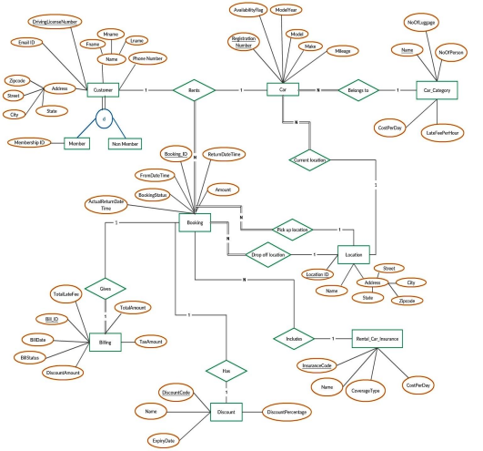7

**Use case diagram-**

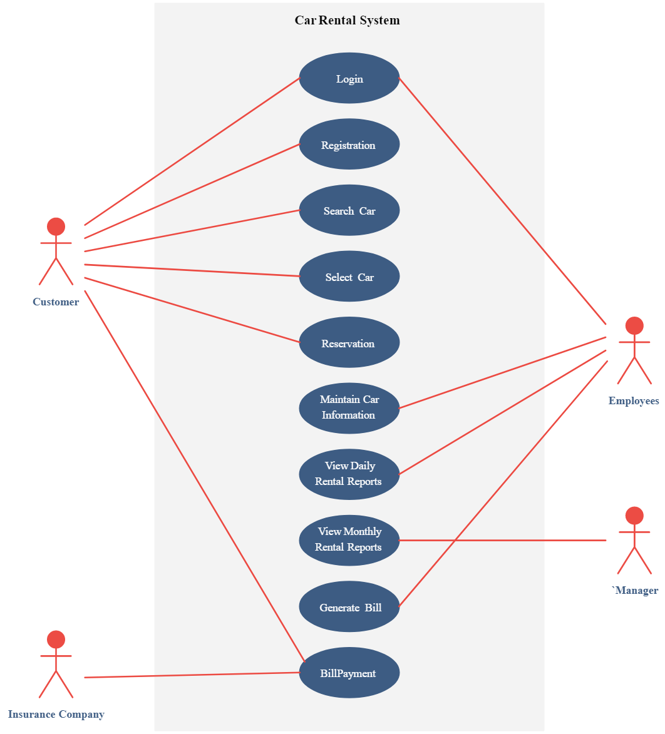

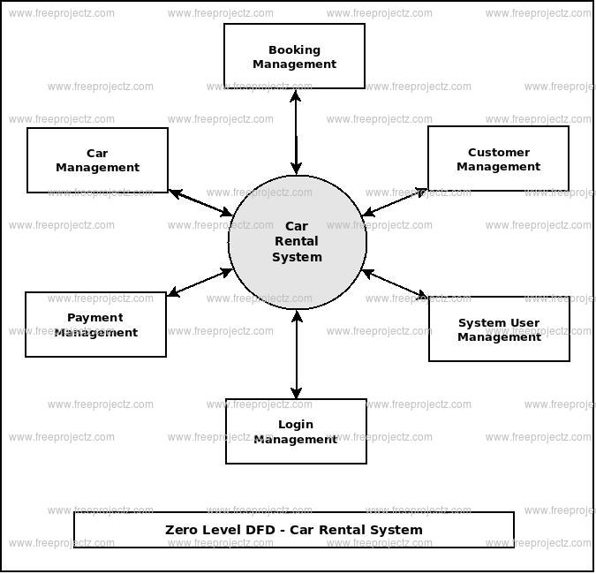

**6. FUNCTIONAL DEPENDENCIES**

**a) Customer_Details Relation:**

∙ DL_number -> Fname, Mname, Lname, Phone_number, Email_id, Street, City, State, Zipcode, Membership_id, Membership_type

∙ Zipcode -> State,City

**b) Car Relation:**

∙ Registration_number -> Model, Make, Model_year, Car_category_name, Loc_id, Mileage, Availability_flag

∙ Model -> Make

**c) Car_Category Relation:**

∙ Category_name -> No_of_luggage, No_of_person, Cost_per_day,

Late_fee_per_hour

**d) Location _Details Relation:**

∙ Location_id -> Name,Street,City,State,Zipcode

∙ Zipcode -> State,City

**e) Booking_Details Relation:**

∙ Booking_id -> From_dt_time, Ret_dt_time, Amount, Booking_status, Pickup_loc, Drop_loc, Reg_num, DL_num, Ins_code, Act_ret_dt_time,

Discount_code

**f) Billing_Details Relation:**

∙ Bill_id -> Bill_date, Bill_status, Discount_amt, Total_amt, Tax_amt, Booking_id, Total_late_fee

**g) Discount_Details Relation:**

∙ Discount_code -> Discount_name,Expiry_date,Discount_percentage ∙ Discount_name -> Discount_code ,Expiry_date,Discount_percentage

8

**h) Rental_Car_Insurance Relation:**

∙ Insurance_code -> Insurance_name,Coverage_type,Cost_per_day ∙ Insurance_name -> Insurance_code ,Coverage_type,Cost_per_day

**6.1 Functional dependencies that violated normalization rules:** The Following transitive dependencies exist in the relational schema.

∙ **Customer_Details Relation**

o DL_number -> Zipcode

o Zipcode -> State, City

∙ **Car Relation**

o Registration_number -> Model_name

o Model_name -> Make

∙ **Location_Details Relation**

o Location_id -> Zipcode

o Zipcode -> State, City

**FINAL RELATIONAL SCHEMA**

For convenience, we have chosen to represent our final relational schema in 2NF normalization. We have de-normalized from 3NF to 2NF.

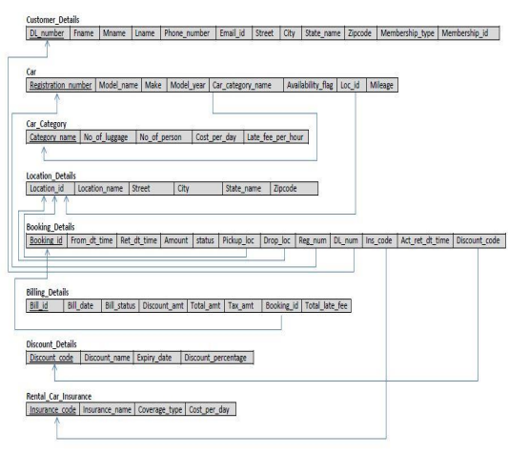10

**8. SQL STATEMENTS**

**8.1 Create table Statements**

a) **Customer_Details**

CREATE TABLE CUSTOMER_DETAILS

( DL_NUMBER CHAR(8) NOT NULL,

FNAME VARCHAR(25) NOT NULL,

MNAME VARCHAR(15),

LNAME VARCHAR(25) NOT NULL,

PHONE_NUMBER NUMBER(10) NOT NULL,

EMAIL_ID VARCHAR(30) NOT NULL,

STREET VARCHAR(30) NOT NULL,

CITY VARCHAR(20) NOT NULL,

STATE_NAME VARCHAR(20) NOT NULL,

ZIPCODE NUMBER(5) NOT NULL,

MEMBERSHIP_TYPE CHAR(1) DEFAULT 'N' NOT NULL, MEMBERSHIP_ID CHAR(5),

CONSTRAINT CUSTOMERPK

PRIMARY KEY (DL_NUMBER)

);

**b) Car_Category**

CREATE TABLE CAR_CATEGORY

( CATEGORY_NAME VARCHAR(25) NOT NULL,

NO_OF_LUGGAGE INTEGER NOT NULL,

NO_OF_PERSON INTEGER NOT NULL,

COST_PER_DAY NUMBER(5,2) NOT NULL,

LATE_FEE_PER_HOUR NUMBER(5,2) NOT NULL, CONSTRAINT CARCATEGORYPK

PRIMARY KEY (CATEGORY_NAME)

);

**c) Location_Details**

CREATE TABLE LOCATION_DETAILS

( LOCATION_ID CHAR(4) NOT NULL,

LOCATION_NAME VARCHAR(50) NOT NULL,

11

STREET VARCHAR(30) NOT NULL,

CITY VARCHAR(20) NOT NULL,

STATE_NAME VARCHAR(20) NOT NULL,

ZIPCODE NUMBER(5) NOT NULL,

CONSTRAINT LOCATIONPK

PRIMARY KEY (LOCATION_ID)

);

**d) Car**

CREATE TABLE CAR

( REGISTRATION_NUMBER CHAR(7) NOT NULL,

MODEL_NAME VARCHAR(25) NOT NULL,

MAKE VARCHAR(25) NOT NULL,

MODEL_YEAR NUMBER(4) NOT NULL,

MILEAGE INTEGER NOT NULL,

CAR_CATEGORY_NAME VARCHAR(25) NOT NULL,

LOC_ID CHAR(4) NOT NULL,

AVAILABILITY_FLAG CHAR(1) NOT NULL,

CONSTRAINT CARPK

PRIMARY KEY (REGISTRATION_NUMBER),

CONSTRAINT CARFK1

FOREIGN KEY (CAR_CATEGORY_NAME) REFERENCES

CAR_CATEGORY(CATEGORY_NAME),

CONSTRAINT CARFK2

FOREIGN KEY (LOC_ID) REFERENCES LOCATION_DETAILS(LOCATION_ID) );

**e) Discount_Details**

CREATE TABLE DISCOUNT_DETAILS

( DISCOUNT_CODE CHAR(4) NOT NULL,

DISCOUNT_NAME VARCHAR(25) NOT NULL,

EXPIRY_DATE DATE NOT NULL,

DISCOUNT_PERCENTAGE NUMBER(4,2) NOT NULL,

CONSTRAINT DISCOUNTPK

PRIMARY KEY (DISCOUNT_CODE),

CONSTRAINT DISCOUNTSK

UNIQUE (DISCOUNT_NAME)

);

12

**f) Rental_Car_Insurance**

CREATE TABLE RENTAL_CAR_INSURANCE

( INSURANCE_CODE CHAR(4) NOT NULL,

INSURANCE_NAME VARCHAR(50) NOT NULL,

COVERAGE_TYPE VARCHAR(200) NOT NULL,

COST_PER_DAY NUMBER(4,2) NOT NULL,

CONSTRAINT INSURANCEPK

PRIMARY KEY (INSURANCE_CODE),

CONSTRAINT INSURANCESK

UNIQUE (INSURANCE_NAME)

);

**g) Booking_Details**

CREATE TABLE BOOKING_DETAILS

( BOOKING_ID CHAR(5) NOT NULL,

FROM_DT_TIME TIMESTAMP NOT NULL,

RET_DT_TIME TIMESTAMP NOT NULL,

AMOUNT NUMBER(10,2) NOT NULL,

BOOKING_STATUS CHAR(1) NOT NULL,

PICKUP_LOC CHAR(4) NOT NULL,

DROP_LOC CHAR(4) NOT NULL,

REG_NUM CHAR(7) NOT NULL,

DL_NUM CHAR(8) NOT NULL,

INS_CODE CHAR(4),

ACT_RET_DT_TIME TIMESTAMP,

DISCOUNT_CODE CHAR(4),

CONSTRAINT BOOKINGPK

PRIMARY KEY (BOOKING_ID),

CONSTRAINT BOOKINGFK1

FOREIGN KEY (PICKUP_LOC) REFERENCES LOCATION_DETAILS(LOCATION_ID), CONSTRAINT BOOKINGFK2

FOREIGN KEY (DROP_LOC) REFERENCES LOCATION_DETAILS(LOCATION_ID), CONSTRAINT BOOKINGFK3

FOREIGN KEY (REG_NUM) REFERENCES CAR(REGISTRATION_NUMBER), CONSTRAINT BOOKINGFK4

FOREIGN KEY (DL_NUM) REFERENCES CUSTOMER_DETAILS(DL_NUMBER), CONSTRAINT BOOKINGFK5

FOREIGN KEY (INS_CODE) REFERENCES RENTAL_CAR_INSURANCE(INSURANCE_CODE),

13

CONSTRAINT BOOKINGFK6

FOREIGN KEY (DISCOUNT_CODE) REFERENCES DISCOUNT_DETAILS(DISCOUNT_CODE) );

**h) Billing_Details**

CREATE TABLE BILLING_DETAILS

( BILL_ID CHAR(6) NOT NULL,

BILL_DATE DATE NOT NULL,

BILL_STATUS CHAR(1) NOT NULL,

DISCOUNT_AMOUNT NUMBER(10,2) NOT NULL,

TOTAL_AMOUNT NUMBER(10,2) NOT NULL,

TAX_AMOUNT NUMBER(10,2) NOT NULL,

BOOKING_ID CHAR(5) NOT NULL,

TOTAL_LATE_FEE NUMBER(10,2) NOT NULL,

CONSTRAINT BILLINGPK

PRIMARY KEY (BILL_ID),

CONSTRAINT BILLINGFK1

FOREIGN KEY (BOOKING_ID) REFERENCES BOOKING_DETAILS(BOOKING_ID) );

**8.2 Insert SQL Statements**

INSERT INTO CUSTOMER_DETAILS VALUES('F1234554', 'NAVEEN',

NULL,'RAJ','4696004267', 'naveen@gmail.com','700 CAMPBELL RD',

'RICHARDSON','TEXAS',75080,'M','M1001');

INSERT INTO CUSTOMER_DETAILS VALUES('F9764521', 'NIVEDITHA',

NULL,'VARADHA CHANDRASEKARAN','4696478596', 'nivi07@gmail.com', '800 RENNER RD','RICHARDSON','TEXAS',75080,'M','M1002');

INSERT INTO CUSTOMER_DETAILS VALUES('F2345611', 'SURESH',

'KUMAR','GOPALAKRISHNAN','8189187546', 'suresh2234@gmail.com',

'6547 CANOGA AVE','CANOGA PARK','CALIFORNIA',91303,'N',NULL);

INSERT INTO CUSTOMER_DETAILS VALUES('R8763578', 'MARK',

NULL,'HUFF','7345678902', 'markhuff@gmail.com','1445 ROSS AVE',

'DALLAS','TEXAS',75202,'N',NULL);

INSERT INTO CUSTOMER_DETAILS VALUES('I3478953', 'MARK',

'S','TOWNSEND','9872563478', 'markstown@gmail.com','7825 MCCALLUM BLVD', 'DALLAS','TEXAS',75252,'M','M1003');

14

INSERT INTO CUSTOMER_DETAILS VALUES('E7521097', 'MITA',

NULL,'RANA','9098123429', 'mitarana@gmail.com','367 MEANDERING WAY', 'HOUSTON','TEXAS',76245,'N',NULL);

INSERT INTO CUSTOMER_DETAILS VALUES('T0981237', 'DANISH',

NULL,'HASSAN','6712890345', 'danishhasan@gmail.com','888 PRESTON ROAD', 'DULLES','VIRGINIA',92367,'M','M1004');

INSERT INTO CUSTOMER_DETAILS VALUES('F0091266', 'MIKE',

NULL,'BOYEAR','7892340918', 'mikeboy@gmail.com','1007 DALLAS PARKWAY', 'DALLAS','TEXAS',72212,'N',NULL);

INSERT INTO CUSTOMER_DETAILS VALUES('P1234567', 'CHRIS',

NULL,'ALEXANDER','9902489', 'chrisalex@gmail.com','2256 WALL STREET', 'NEWARK','NEW JERSEY',65289,'M','M1005');

INSERT INTO CUSTOMER_DETAILS VALUES('V5690245',

'VELA','R','REYNALDO','9908762514', 'reyvela@gmail.com','0099 ALMA ROAD', 'DULLES','VIRGINIA',97325,'N',NULL);

INSERT INTO CAR_CATEGORY VALUES('ECONOMY',2,5,30,0.9);

INSERT INTO CAR_CATEGORY VALUES('COMPACT',3,5,32,0.96);

INSERT INTO CAR_CATEGORY VALUES('MID SIZE',3,5,35,1.05);

INSERT INTO CAR_CATEGORY VALUES('STANDARD',3,5,38,1.14);

INSERT INTO CAR_CATEGORY VALUES('FULL SIZE',4,5,40,1.2);

INSERT INTO CAR_CATEGORY VALUES('LUXURY CAR',5,5,75,2.25);

INSERT INTO CAR_CATEGORY VALUES('MID SIZE SUV',2,5,36,1.08); INSERT INTO CAR_CATEGORY VALUES('STANDARD SUV',3,5,40,1.2); INSERT INTO CAR_CATEGORY VALUES('FULL SIZE SUV',2,8,60,1.8);

INSERT INTO CAR_CATEGORY VALUES('MINI VAN',5,7,70,2.1);

INSERT INTO LOCATION_DETAILS VALUES('L101','DALLAS LOVE FIELD AIRPORT', 'Herb Kelleher Way','Dallas','Texas',75235);

INSERT INTO LOCATION_DETAILS VALUES('L102','LOS ANGELES INTL AIRPORT', 'World Way','Los Angeles','California',90045);

INSERT INTO LOCATION_DETAILS VALUES('L103','DALLAS/ FORT WORTH INTL AIRPORT', 'International Pkwy','DFW Airport','Texas',75261);

INSERT INTO LOCATION_DETAILS VALUES('L104','WEST HOUSTON AIRPORT', 'Groschke Rd','Houston','Texas',77094);

INSERT INTO LOCATION_DETAILS VALUES('L105','WASHINGTON DULLES INTL AIRPORT',

15

'Saarinen Cir','Dulles','Virginia',20166);

INSERT INTO LOCATION_DETAILS VALUES('L106','NEWARK LIBERTY INTL AIRPORT', 'Brewster Rd','Newark','New Jersey',07114);

INSERT INTO LOCATION_DETAILS VALUES('L107','SALT LAKE CITY INTL AIRPORT', 'N Terminal Dr','Salt Lake City','Utah',84122);

INSERT INTO CAR VALUES('ABX1234','CIVIC','HONDA',

2014,10000,'ECONOMY','L101','A');

INSERT INTO CAR VALUES('SDF4567','FIESTA','FORD',

2015,15000,'ECONOMY','L102','N');

INSERT INTO CAR VALUES('WER3245','ACCENT','HYUNDAI',

2014,12356,'ECONOMY','L103','A');

INSERT INTO CAR VALUES('GLZ2376','COROLLA','TOYOTA',

2016,5000,'ECONOMY','L104','A');

INSERT INTO CAR VALUES('HJK1234','CIVIC','HONDA',

2015,20145,'ECONOMY','L102','N');

INSERT INTO CAR VALUES('GLS7625','FOCUS','FORD',

2014,12000,'COMPACT','L107','A');

INSERT INTO CAR VALUES('FKD8202','GOLF','VOLKSWAGAN',

2016,9000,'COMPACT','L106','A');

INSERT INTO CAR VALUES('HNX1890','PRIUS','TOYOTA',

2015,15690,'COMPACT','L105','N');

INSERT INTO CAR VALUES('KJS1983','PRIUS','TOYOTA',

2014,20900,'COMPACT','L104','A');

INSERT INTO CAR VALUES('SDL9356','FOCUS','FORD',

2016,10009,'COMPACT','L103','A');

INSERT INTO CAR VALUES('OTY7293','CRUZE','CHEVROLET',

2016,17800,'MID SIZE','L102','A');

INSERT INTO CAR VALUES('QWE4562','LEGACY','SUBARU',

2012,13420,'MID SIZE','L101','A');

INSERT INTO CAR VALUES('CXZ2356','AVENGER','DODGE',

2015,5000,'MID SIZE','L102','A');

INSERT INTO CAR VALUES('ASD9090','ACCORD','HONDA',

2016,200,'MID SIZE','L103','A');

INSERT INTO CAR VALUES('UYT3981','LEGACY','SUBARU',

2013,16750,'MID SIZE','L104','A');

INSERT INTO CAR VALUES('TRE9726','200','CHRYSTLER',

16

2012,14320,'STANDARD','L105','A');

INSERT INTO CAR VALUES('HGF5628','TAURUS','FORD', 2013,15540,'STANDARD','L106','A');

INSERT INTO CAR VALUES('LKJ7253','200','CHRYSTLER', 2014,16300,'STANDARD','L107','A');

INSERT INTO CAR VALUES('VBN6283','TAURUS','FORD', 2015,17500,'STANDARD','L101','A');

INSERT INTO CAR VALUES('POI7281','200','CHRYSTLER', 2016,18830,'STANDARD','L102','N');

INSERT INTO CAR VALUES('MNB8654','FALCON','FORD', 2012,10900,'FULL SIZE','L103','A');

INSERT INTO CAR VALUES('UHV9786','IMPALA','CHEVROLET', 2013,11500,'FULL SIZE','L104','A');

INSERT INTO CAR VALUES('EFB5427','WAYFARER','FORD', 2014,14350,'FULL SIZE','L105','A');

INSERT INTO CAR VALUES('PLM9873','IMPALA','CHEVROLET', 2015,18900,'FULL SIZE','L106','A');

INSERT INTO CAR VALUES('WDV2458','FALCON','FORD', 2016,5600,'FULL SIZE','L107','A');

INSERT INTO CAR VALUES('QSC8709','MKZ','LINCOLN', 2012,18700,'LUXURY CAR','L101','A');

INSERT INTO CAR VALUES('TGB8961','GENESIS','HYUNDAI', 2013,17620,'LUXURY CAR','L102','A');

INSERT INTO CAR VALUES('MKU0172','TLX','ACURA', 2014,12345,'LUXURY CAR','L103','A');

INSERT INTO CAR VALUES('CFT1908','328I','BMW', 2015,10800,'LUXURY CAR','L104','A');

INSERT INTO CAR VALUES('WHM7619','AVALON','TOYOTA', 2016,7800,'LUXURY CAR','L105','A');

INSERT INTO CAR VALUES('WLZ8955','ESCAPE','FORD', 2012,19800,'MID SIZE SUV','L106','A');

INSERT INTO CAR VALUES('QIO7621','EQUINOX','CHEVROLET', 2013,17560,'MID SIZE SUV','L107','A');

INSERT INTO CAR VALUES('YSN1927','PATHFINDER','NISSAN', 2014,14390,'MID SIZE SUV','L101','A');

INSERT INTO CAR VALUES('EDM8610','GLA','MERCEDEZ BENZ', 2015,12900,'MID SIZE SUV','L102','A');

INSERT INTO CAR VALUES('AHK7325','RAV4','TOYOTA',

17

2016,3400,'MID SIZE SUV','L103','A');

INSERT INTO CAR VALUES('OHZ0976','EDGE','FORD', 2012,27890,'STANDARD SUV','L104','A');

INSERT INTO CAR VALUES('RKS9862','TAHOE','CHEVROLET', 2013,20390,'STANDARD SUV','L105','A');

INSERT INTO CAR VALUES('WIJ6190','EDGE','FORD',

2014,18700,'STANDARD SUV','L106','A');

INSERT INTO CAR VALUES('ZDT8612','TAHOE','CHEVROLET', 2015,14300,'STANDARD SUV','L107','A');

INSERT INTO CAR VALUES('LDJ7719','EDGE','FORD',

2016,5690,'STANDARD SUV','L101','A');

INSERT INTO CAR VALUES('UIA8709','EXPEDITION','FORD', 2012,19870,'FULL SIZE SUV','L102','A');

INSERT INTO CAR VALUES('WKJ7972','SEQUOIA','TOYOTA', 2013,14500,'FULL SIZE SUV','L103','A');

INSERT INTO CAR VALUES('JLS1097','SUBURBAN','CHEVROLET', 2014,13290,'FULL SIZE SUV','L104','A');

INSERT INTO CAR VALUES('UHJ6782','EXPEDITION','FORD', 2015,11750,'FULL SIZE SUV','L105','A');

INSERT INTO CAR VALUES('XBM6822','SUBURBAN','CHEVROLET', 2016,3400,'FULL SIZE SUV','L106','A');

INSERT INTO CAR VALUES('SHK7767','QUEST','NISSAN', 2012,23478,'MINI VAN','L107','A');

INSERT INTO CAR VALUES('JSL7920','ODYSSEY','HONDA', 2013,19320,'MINI VAN','L106','A');

INSERT INTO CAR VALUES('PAJ5289','GRAND CARAVAN','DODGE', 2014,23478,'MINI VAN','L105','A');

INSERT INTO CAR VALUES('TSJ6290','QUEST','NISSAN', 2015,13200,'MINI VAN','L104','A');

INSERT INTO CAR VALUES('MWO9296','ODYSSEY','HONDA', 2016,2300,'MINI VAN','L103','A');

INSERT INTO DISCOUNT_DETAILS VALUES ('D678','IBM CORPORATE', to_date('2018-01-25','YYYY-MM-DD'),25);

INSERT INTO DISCOUNT_DETAILS VALUES ('D234','CTS CORPORATE', to_date('2019-09-02','YYYY-MM-DD'),20);

INSERT INTO DISCOUNT_DETAILS VALUES ('D756','HOLIDAY SPECIAL',

18

to_date('2017-10-29','YYYY-MM-DD'),10);

INSERT INTO DISCOUNT_DETAILS VALUES ('D109','WEEKLY RENTALS', to_date('2020-11-09','YYYY-MM-DD'),25);

INSERT INTO DISCOUNT_DETAILS VALUES ('D972','ONE WAY SPECIAL', to_date('2016-12-15','YYYY-MM-DD'),20);

INSERT INTO DISCOUNT_DETAILS VALUES ('D297','UPGRADE SPECIAL', to_date('2018-02-18','YYYY-MM-DD'),20);

INSERT INTO RENTAL_CAR_INSURANCE VALUES('I201', 'COLLISION DAMAGE WAIVER', 'Covers theft and total damage to the rental car',15);

INSERT INTO RENTAL_CAR_INSURANCE VALUES('I202',

'SUPPLEMENTAL LIABILITY PROTECTION', 'Covers damage done to others',12); INSERT INTO RENTAL_CAR_INSURANCE VALUES('I203',

'PERSONAL ACCIDENT INSURANCE', 'Covers medical costs for driver and passengers',10); INSERT INTO RENTAL_CAR_INSURANCE VALUES('I204',

'PERSONAL EFFECTS COVERAGE', 'Covers theft of personal belongings',5);

INSERT INTO BOOKING_DETAILS VALUES('B1001',TO_TIMESTAMP('2016-01-20 10:00:00', 'YYYY-MM-DD HH24:MI:SS'),TO_TIMESTAMP('2016-01-25 10:00:00', 'YYYY-MM-DD HH24:MI:SS'),

150,'R','L101','L101','ABX1234','F1234554',NULL,

TO_TIMESTAMP('2016-01-25 10:00:00', 'YYYY-MM-DD HH24:MI:SS'),'D756'); INSERT INTO BOOKING_DETAILS VALUES('B1002',TO_TIMESTAMP('2016-01-21 11:00:00', 'YYYY-MM-DD HH24:MI:SS'),TO_TIMESTAMP('2016-01-24 10:00:00', 'YYYY-MM-DD HH24:MI:SS'),

90,'C','L102','L102','SDF4567','T0981237',NULL,NULL,NULL);

INSERT INTO BOOKING_DETAILS VALUES('B1003',TO_TIMESTAMP('2016-02-10 13:00:00', 'YYYY-MM-DD HH24:MI:SS'),TO_TIMESTAMP('2016-01-15 13:00:00', 'YYYY-MM-DD HH24:MI:SS'),

450,'R','L101','L101','QSC8709','R8763578','I201',

TO_TIMESTAMP('2016-01-15 13:00:00', 'YYYY-MM-DD HH24:MI:SS'),NULL); INSERT INTO BOOKING_DETAILS VALUES('B1004',TO_TIMESTAMP('2016-04-24 13:00:00', 'YYYY-MM-DD HH24:MI:SS'),TO_TIMESTAMP('2016-04-25 20:30:00', 'YYYY-MM-DD HH24:MI:SS'),

48,'R','L106','L106','WLZ8955','F0091266','I202',

TO_TIMESTAMP('2016-04-23 20:30:00', 'YYYY-MM-DD HH24:MI:SS'),'D234');

19

INSERT INTO BOOKING_DETAILS VALUES('B1005',TO_TIMESTAMP('2016-04-18 09:00:00', 'YYYY-MM-DD HH24:MI:SS'),TO_TIMESTAMP('2016-04-25 09:00:00', 'YYYY-MM-DD HH24:MI:SS'),

266,'B','L102','L106','POI7281','P1234567',NULL,NULL,'D972');

INSERT INTO BOOKING_DETAILS VALUES('B1006',TO_TIMESTAMP('2016-04-21 17:00:00', 'YYYY-MM-DD HH24:MI:SS'),TO_TIMESTAMP('2016-04-25 17:00:00', 'YYYY-MM-DD HH24:MI:SS'),

168,'B','L105','L107','HNX1890','V5690245','I203',NULL,'D234');

INSERT INTO BOOKING_DETAILS VALUES('B1007',TO_TIMESTAMP('2016-04-16 08:00:00', 'YYYY-MM-DD HH24:MI:SS'),TO_TIMESTAMP('2016-04-25 17:00:00', 'YYYY-MM-DD HH24:MI:SS'),

405,'B','L102','L102','SDF4567','I3478953','I201',NULL,'D756');

INSERT INTO BOOKING_DETAILS VALUES('B1008',TO_TIMESTAMP('2016-04-11 08:00:00', 'YYYY-MM-DD HH24:MI:SS'),TO_TIMESTAMP('2016-04-25 17:00:00', 'YYYY-MM-DD HH24:MI:SS'),

630,'B','L102','L102','HJK1234','T0981237','I201',NULL,'D756');

INSERT INTO BILLING_DETAILS VALUES('BL1001',to_date('2016-01-25','YYYY-MM-DD'), 'P',24.36 ,138.03,12.38 ,'B1001',0);

INSERT INTO BILLING_DETAILS VALUES('BL1002',to_date('2016-01-15','YYYY-MM-DD'), 'P',0 ,487.13 ,12.38 ,'B1003',0);

INSERT INTO BILLING_DETAILS VALUES('BL1003',to_date('2016-04-24','YYYY-MM-DD'), 'P',10.39 ,41.57 ,3.96 ,'B1004',0);

**9. PL/SQL STATEMEMTS**

**9.1 Stored Procedure 1: CALCULATE_LATE_FEE_AND_TAX**

Given the return date and time while booking, actual return date and time, registration number of the car and booking amount, this procedure calculates the total late fee using late fee per hour, return date and time and the actual return date and time of the rental car. Once the total late fee is obtained, it is added to the amount and the total tax is calculated.

20

-------------------------------------------------------------------------------------------

--Procedure Name: CALCULATE_LATE_FEE_AND_TAX

--This stored procedure calculates the total late fee and tax.

-------------------------------------------------------------------------------------------

CREATE OR REPLACE PROCEDURE CALCULATE_LATE_FEE_AND_TAX

(actualReturnDateTime IN BOOKING_DETAILS.ACT_RET_DT_TIME%TYPE, ReturnDateTime IN BOOKING_DETAILS.RET_DT_TIME%TYPE,

regNum IN BOOKING_DETAILS.REG_NUM%TYPE,

amount IN BOOKING_DETAILS.AMOUNT%TYPE,

totalLateFee OUT BILLING_DETAILS.TOTAL_AMOUNT%TYPE,

totalTax OUT BILLING_DETAILS.TAX_AMOUNT%TYPE ) AS

--local declarations

lateFeePerHour CAR_CATEGORY.LATE_FEE_PER_HOUR%TYPE;

hourDifference DECIMAL(10,2);

BEGIN

SELECT LATE_FEE_PER_HOUR INTO lateFeePerHour

FROM CAR_CATEGORY CC INNER JOIN CAR C ON CC.CATEGORY_NAME = C.CAR_CATEGORY_NAME WHERE C.REGISTRATION_NUMBER = regNum;

IF actualReturnDateTime > ReturnDateTime THEN

hourDifference := (TO_DATE (TO_CHAR (actualReturnDateTime,

'dd/mm/yyyy hh24:mi:ss'), 'dd/mm/yyyy hh24:mi:ss')

- TO_DATE (TO_CHAR (ReturnDateTime, 'dd/mm/yyyy hh24:mi:ss') ,'dd/mm/yyyy hh24:mi:ss'))*(24);

totalLateFee := hourDifference * lateFeePerHour;

ELSE

totalLateFee := 0;

END IF;

totalTax := (amount + totalLateFee)*0.0825;

END;

/

**9.2 Stored Procedure 2: CALCULATE_DISCOUNT_AMOUNT**

Given the driving license number, total amount and the discount code, this procedure calculates the discount amount based on the discount code used by the customer while booking the rental car. Additional 10% discount is given to the customers who have membership ID. The discount amount is calculated on the total amount obtained after adding the late fee and the tax amount.

∙ For Non-members:

21

Discount amount = total amount * ((discountPercentage)/100)

∙ For members:

Discount amount = total amount * ((discountPercentage+10)/100)

------------------------------------------------------------------------------------------- --Procedure Name: CALCULATE_DISCOUNT_AMOUNT

--This stored procedure calculates the discount amount for a booking. ------------------------------------------------------------------------------------------- CREATE OR REPLACE PROCEDURE CALCULATE_DISCOUNT_AMOUNT (dlNum IN CUSTOMER_DETAILS.DL_NUMBER%TYPE,

amount IN BILLING_DETAILS.TOTAL_AMOUNT%TYPE,

discountCode IN DISCOUNT_DETAILS.DISCOUNT_CODE%TYPE,

discountAmt OUT BILLING_DETAILS.DISCOUNT_AMOUNT%TYPE) AS --local declarations

memberType CUSTOMER_DETAILS.MEMBERSHIP_TYPE%TYPE;

discountPercentage DISCOUNT_DETAILS.DISCOUNT_PERCENTAGE%TYPE; BEGIN

SELECT MEMBERSHIP_TYPE INTO memberType FROM CUSTOMER_DETAILS WHERE DL_NUMBER = dlNum;

IF NVL(discountCode,'NULL') <> 'NULL' THEN

SELECT DISCOUNT_PERCENTAGE INTO discountPercentage FROM DISCOUNT_DETAILS WHERE DISCOUNT_CODE = discountCode; IF memberType = 'M' THEN

discountAmt := amount * ((discountPercentage+10)/100); ELSE

discountAmt := amount * (discountPercentage/100); END IF;

ELSE

IF memberType = 'M' THEN

discountAmt := amount * 0.1;

ELSE

discountAmt := 0;

END IF;

END IF;

END;

/

22

**9.3 Stored Procedure 3: GENERATE_REVENUE_REPORT**

This procedure generates monthly revenue report based on the bill date, location and car categories. For every location, the no of cars in each car category along with the total revenue is calculated and a monthly report is generated. This stored procedure makes use of cursor for report generation.

-------------------------------------------------------------------------------------------

--Procedure Name: GENERATE_REVENUE_REPORT

--This stored procedure calculates and generates the monthly revenue report. -------------------------------------------------------------------------------------------

CREATE OR REPLACE PROCEDURE GENERATE_REVENUE_REPORT AS

--local declarations

thisLocationID LOCATION_DETAILS.LOCATION_ID%TYPE;

currentLocationID LOCATION_DETAILS.LOCATION_ID%TYPE;

locationName LOCATION_DETAILS.LOCATION_NAME%TYPE;

thisCategoryName CAR_CATEGORY.CATEGORY_NAME%TYPE;

thisNoOfCars integer; thisRevenue DECIMAL(15,2);

--Cursor declaration

CURSOR CURSOR_REPORT IS SELECT TABLE1.LOCATIONID, TABLE1.CATNAME , TABLE1.NOOFCARS,SUM(NVL((TABLE2.AMOUNT),0)) AS REVENUE

FROM (SELECT LC.LID AS LOCATIONID, LC.CNAME AS CATNAME ,

COUNT(C.REGISTRATION_NUMBER) AS NOOFCARS FROM (SELECT

L.LOCATION_ID AS LID, CC.CATEGORY_NAME AS CNAME FROM

CAR_CATEGORY CC CROSS JOIN LOCATION_DETAILS L) LC LEFT OUTER JOIN CAR C ON LC.CNAME = C.CAR_CATEGORY_NAME AND LC.LID = C.LOC_ID GROUP BY LC.LID, LC.CNAME ORDER BY LC.LID) TABLE1 LEFT OUTER JOIN (SELECT BC.PLOC AS PICKLOC,BC.CNAME AS CNAMES, SUM(BL.TOTAL_AMOUNT) AS AMOUNT FROM (SELECT B.PICKUP_LOC AS PLOC, C1.CAR_CATEGORY_NAME AS CNAME, B.BOOKING_ID AS BID FROM BOOKING_DETAILS B INNER JOIN CAR C1 ON B.REG_NUM = C1.REGISTRATION_NUMBER) BC INNER JOIN BILLING_DETAILS BL ON BC.BID = BL.BOOKING_ID WHERE

(to_date (SYSDATE,'dd-MM-yyyy') - to_date(BL.BILL_DATE,'dd-MM-yyyy')) <=30 GROUP BY BC.PLOC,BC.CNAME ORDER BY BC.PLOC) TABLE2

ON TABLE1.LOCATIONID=TABLE2.PICKLOC AND TABLE1.CATNAME = TABLE2.CNAMES GROUP BY TABLE1.LOCATIONID, TABLE1.CATNAME, TABLE1.NOOFCARS ORDER BY TABLE1.LOCATIONID;

BEGIN

dbms_output.put_line(' ');

dbms_output.put_line('Revenue Report');

dbms_output.put_line('**************');

23

dbms_output.put_line(' ');

OPEN CURSOR_REPORT;

FETCH CURSOR_REPORT INTO thisLocationID, thisCategoryName, thisNoOfCars, thisRevenue;

IF CURSOR_REPORT%NOTFOUND THEN

dbms_output.put_line('No Report to be Generated');

ELSE

currentLocationID := thisLocationID;

<<LABEL_NEXTLOC>>

SELECT LOCATION_NAME INTO locationName from LOCATION_DETAILS WHERE LOCATION_ID = currentLocationID;

dbms_output.put_line('Location Name: '|| locationName); dbms_output.put_line(' ');

dbms_output.put_line('Car Category' || ' '||'Number of Cars' ||' '|| 'Revenue');

dbms_output.put_line('------------' || ' '||'--------------' ||' '|| '-------');

dbms_output.put_line(thisCategoryName ||

RPAD(' ', (16 - LENGTH(thisCategoryName)))||thisNoOfCars ||RPAD(' ', (18 - LENGTH(thisNoOfCars)))|| thisRevenue); LOOP

FETCH CURSOR_REPORT INTO thisLocationID, thisCategoryName, thisNoOfCars, thisRevenue;

EXIT WHEN (CURSOR_REPORT%NOTFOUND);

IF thisLocationID = currentLocationID THEN

dbms_output.put_line(thisCategoryName || RPAD(' ', (16 - LENGTH(thisCategoryName)))||thisNoOfCars ||RPAD(' ', (18 - LENGTH(thisNoOfCars)))|| thisRevenue); ELSE

currentLocationID := thisLocationID;

dbms_output.put_line(' ');

dbms_output.put_line('*********************** *********************************************

***************

**********************');

dbms_output.put_line(' ');

GOTO LABEL_NEXTLOC;

END IF;

END LOOP;

END IF;

END;

/

24

**9.4 Trigger 1: GENERATE_BILLING**

This trigger inserts a tuple into the Billing_Details table when the actual return date is updated and booking status is updated to ‘R’ in Booking_Details table. It generates Bill when the rental car is returned. This is triggered whenever a row is updated in Booking_Details table.

-------------------------------------------------------------------------------------------

--Trigger Name: GENERATE_BILLING

--This trigger generates the bill and inserts a row in Billing_Details table

-------------------------------------------------------------------------------------------

CREATE OR REPLACE TRIGGER GENERATE_BILLING

AFTER UPDATE ON BOOKING_DETAILS

FOR EACH ROW

WHEN (NVL(TO_CHAR(NEW.ACT_RET_DT_TIME),'NULL') <> 'NULL' AND

NEW.BOOKING_STATUS ='R')

DECLARE

-- declaration section

lastBillId BILLING_DETAILS.BILL_ID%TYPE;

newBillId BILLING_DETAILS.BILL_ID%TYPE;

discountAmt BILLING_DETAILS.DISCOUNT_AMOUNT%TYPE;

totalLateFee BILLING_DETAILS.TOTAL_LATE_FEE%TYPE;

totalTax BILLING_DETAILS.TAX_AMOUNT%TYPE;

totalAmountBeforeDiscount BILLING_DETAILS.TOTAL_AMOUNT%TYPE;

finalAmount BILLING_DETAILS.TOTAL_AMOUNT%TYPE;

BEGIN

SELECT BILL_ID INTO lastBillId FROM ( SELECT BILL_ID, ROWNUM AS

RN FROM BILLING_DETAILS)

WHERE RN= (SELECT MAX(ROWNUM) FROM BILLING_DETAILS);

newBillId := 'BL' || TO_CHAR(TO_NUMBER(SUBSTR(lastBillId,3))+1);

CALCULATE_LATE_FEE_AND_TAX(:NEW.ACT_RET_DT_TIME, :NEW.RET_DT_TIME, :NEW.REG_NUM,:NEW.AMOUNT, totalLateFee, totalTax);

totalAmountBeforeDiscount := :NEW.AMOUNT + totalLateFee + totalTax;

CALCULATE_DISCOUNT_AMOUNT(:NEW.DL_NUM, totalAmountBeforeDiscount, :NEW.DISCOUNT_CODE, discountAmt);

25

finalAmount := totalAmountBeforeDiscount - discountAmt;

--insert new bill into the billing_details table

INSERT INTO BILLING_DETAILS (BILL_ID,BILL_DATE,BILL_STATUS,DISCOUNT_AMOUNT, TOTAL_AMOUNT,TAX_AMOUNT,BOOKING_ID,TOTAL_LATE_FEE)

VALUES (newBillId,to_date(SYSDATE,'YYYY-MM-DD'),'P',

discountAmt,finalAmount,totalTax,:NEW.BOOKING_ID,totalLateFee);

END;

/

**9.5 Trigger 2: UPDATE_CAR_DETAILS**

This trigger updates the availability flag, mileage and location of the car in the car table when the actual return date is updated or when a booking is cancelled. This is triggered whenever a row is updated in Booking_Details table.

-------------------------------------------------------------------------------------------

--Trigger Name: UPDATE_CAR_DETAILS

--This trigger updates the availability flag, mileage and location in the car table --when the car is returned.

-------------------------------------------------------------------------------------------

CREATE OR REPLACE TRIGGER UPDATE_CAR_DETAILS

AFTER UPDATE ON BOOKING_DETAILS

FOR EACH ROW

WHEN (NVL(TO_CHAR(NEW.ACT_RET_DT_TIME),'NULL') <> 'NULL' OR

NEW.BOOKING_STATUS ='C')

DECLARE

BEGIN

IF :NEW.BOOKING_STATUS ='C' THEN

UPDATE CAR SET AVAILABILITY_FLAG = 'A' , LOC_ID = :NEW.PICKUP_LOC WHERE REGISTRATION_NUMBER = :NEW.REG_NUM;

ELSE

IF NVL(TO_CHAR(:NEW.ACT_RET_DT_TIME),'NULL') <> 'NULL' THEN UPDATE CAR SET AVAILABILITY_FLAG = 'A' , LOC_ID = :NEW.DROP_LOC, MILEAGE = MILEAGE+GET_MILEAGE WHERE REGISTRATION_NUMBER = :NEW.REG_NUM;

END IF;

END IF;

END;

/

26

**10.CONCLUSION**

During the course of this project, we learnt a lot of the work and best practices that go into creating a database, the rules to construct a good ER diagram, How to come up with relational schema mapping from the ER diagram, deriving the functional dependencies and how to normalize the relational schema. We learnt on how to design a system from Database perspective and how to efficiently store and manipulate data.

27